Harsh

201105018

Batch B

1

Theory: The Fibonacci sequence is a series of numbers where a number is the addition of the last two numbers, starting with 0, and 1. The Fibonacci Sequence: 0, 1, 1, 2, 3, 5, 8, 13, 21

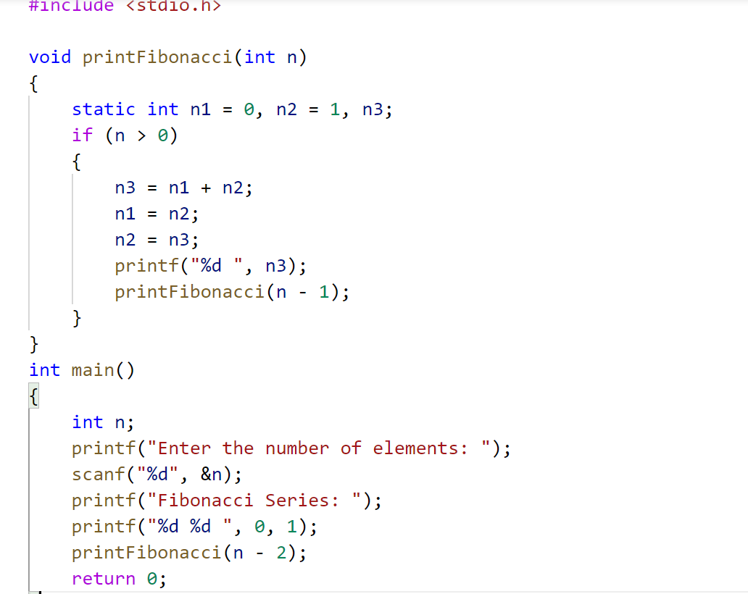

Output:



Conclusion: recursion can be easily used to generate Fibonacci series.

2

Theory: To find the factorial of a number, multiply the number with the factorial value of the previous number.

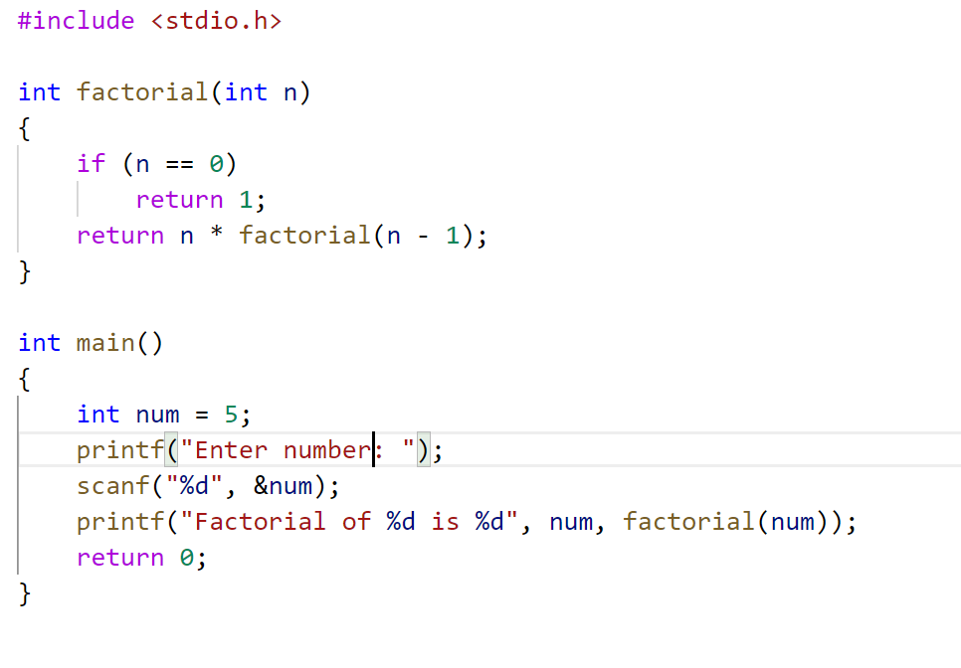

Output:



Conclusion: recursion can be easily used to find factorial of a number.

3

Theory: An array is a data structure that contains a group of elements.

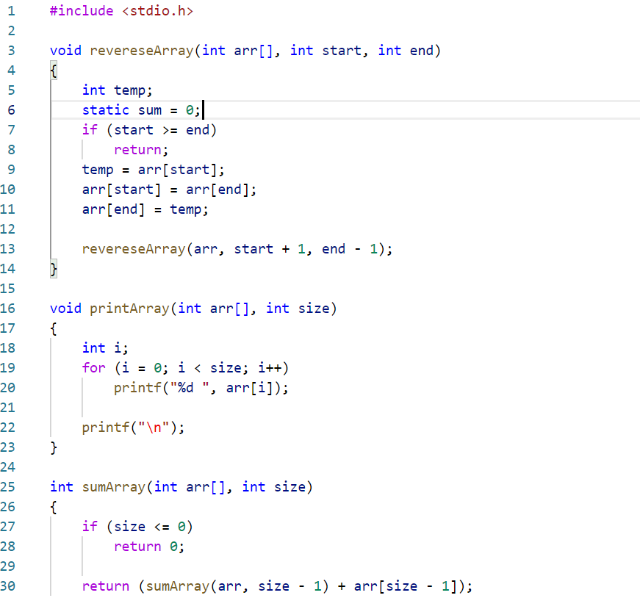

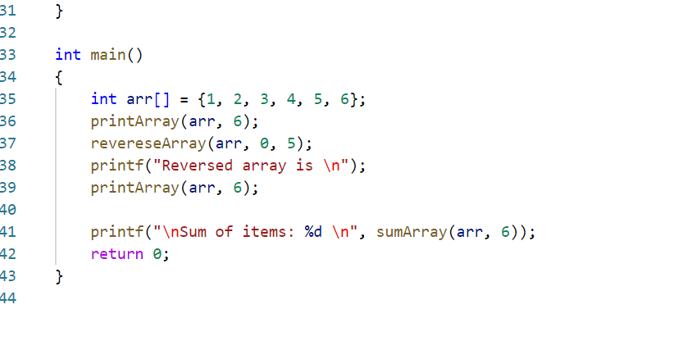Ouput:

Output

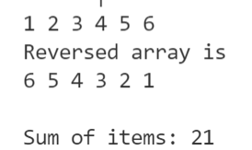

Conclusion: recursion can be easily used to reverse an array

4

Theory: Structures allow us to combine elements of a different data type into a group.

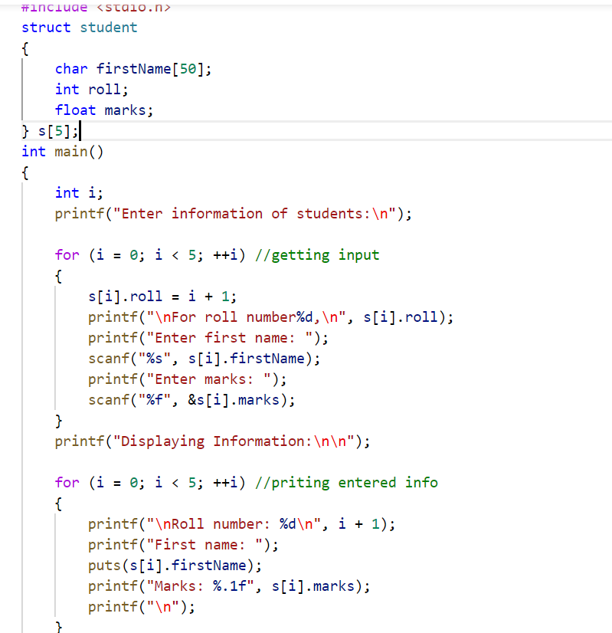

Output:

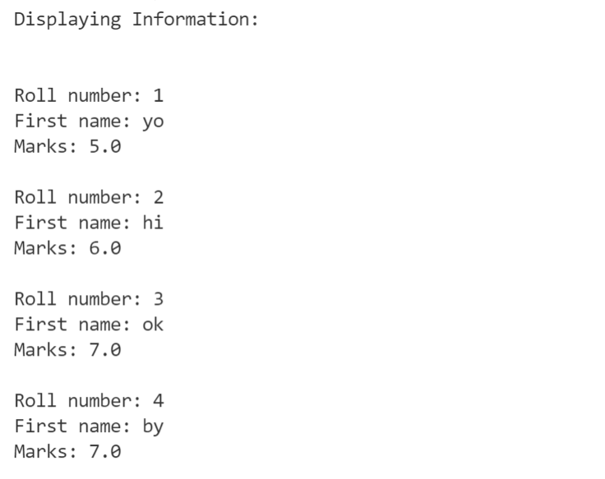

Conclusion: Structures make code maintainable

5

Theory: Structures allow us to combine elements of a different data type into a group.

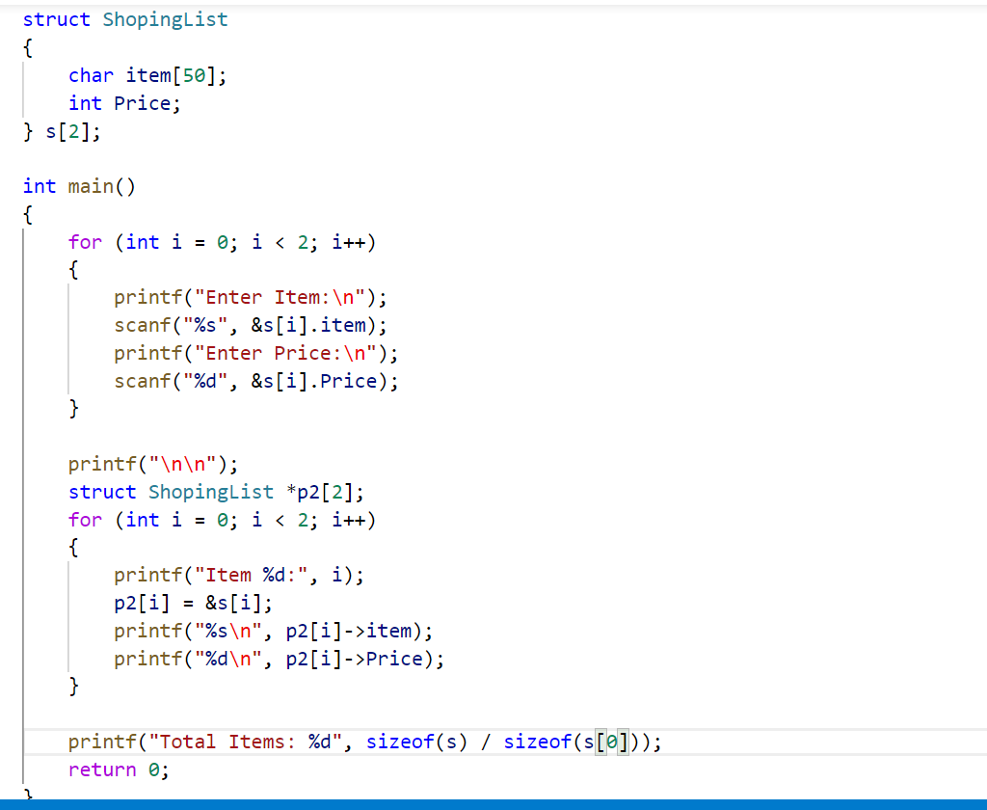

Output:

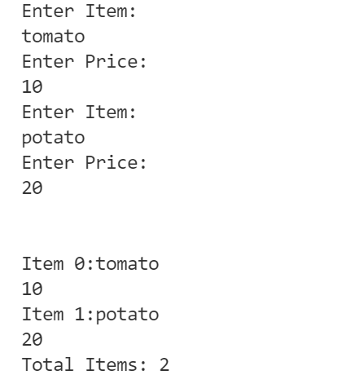

Conclusion: Points can be easily used for structures like any other data type.